Windows Update後，進入SSMS，點選新增查詢，出現以下錯誤

No EditorOptionDefinition export found for the given option name:Tabs/TabSize

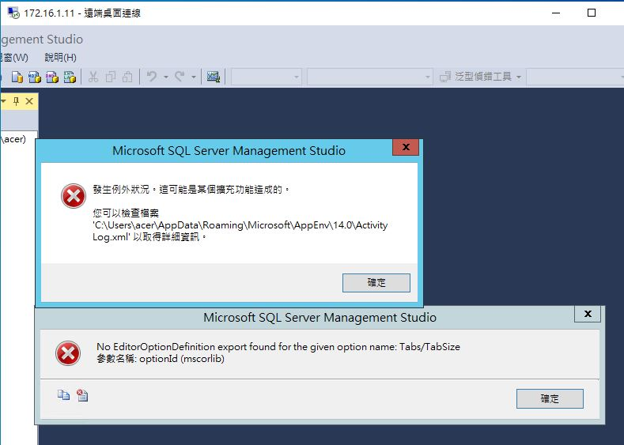

1. 關閉SSMS
2. 開啟 %LocalAppData%\Microsoft\SQL Server Management Studio\13.0
3. 將ComponentModelCache隨便Rename
4. 重啟SSMS即可

